**Practical no. 2**

**FS19CO042**

**Aim:** Performfollowing programs.

2.1 Write a program to print “Hello World”.

2.2 Write a program to print addition of two integers.

2.3 Write a program to convert a numeric string into int.

2.4 Write a program to print addition of two integers input from command line arguments.

2.5 Write a program to take two integers from command line, subtract the smaller number from the greater and print the result.

2.6 Write a program to take n integers from command line and print their sum of product (product of first number and last number added to product of second number and second last number and so on).

2.7 Consider any two integers. Write a program to print sum of their squares.

2.8 Write a program to find square root of a given positive integer using Heron’s method to find square root.

2.9 Write a program to sort and print the names of students taken from command line in alphabetical order.

2.10 Write a program to print total numbers of vowels and consonants in a given string.

2.11 Given two English words, write a program to check if the first word is anagram of the second word. ( An anagram is a word or phrase formed by rearranging the letters of a different word or phrase, typically using all the original letters exactly once. (Example: Anagram of TOM MARVOLO RIDDLE is I AM LORD VOLDEMORT.)

2.12 Write a program to print a missing number in a sorted integer array.

2.13 Write a program to find all the pairs of numbers on an integer array whose sum is equal to a given number.

**Tool used:** Editor (Notepad/Intellij IDE), JDK and JRE

**Theory:**

Data Types in Java

Data types specify the different sizes and values that can be stored in the variable. There are two types of data types in Java:

1. **Primitive data types:** The primitive data types include boolean, char, byte, short, int, long, float and double.
2. **Non-primitive data types:** The non-primitive data types include [Classes](https://www.javatpoint.com/object-and-class-in-java), [Interfaces](https://www.javatpoint.com/interface-in-java), and [Arrays](https://www.javatpoint.com/array-in-java).

Java Primitive Data Types

In Java language, primitive data types are the building blocks of data manipulation. These are the most basic data types available in [Java language](https://www.javatpoint.com/java-tutorial).

There are 8 types of primitive data types:

* boolean data type
* byte data type
* char data type
* short data type
* int data type
* long data type
* float data type
* double data type

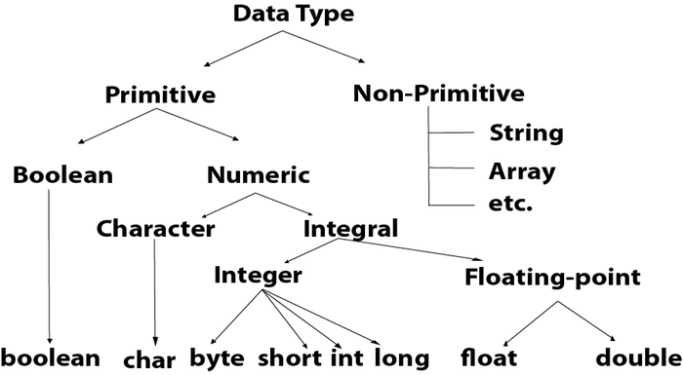

## Boolean Data Type

The Boolean data type is used to store only two possible values: true and false. This data type is used for simple flags that track true/false conditions.

The Boolean data type specifies one bit of information, but its "size" can't be defined precisely.

**Example:** Boolean one = false

## Byte Data Type

The byte data type is an example of primitive data type. It isan 8-bit signed two's complement integer. Its value-range lies between -128 to 127 (inclusive). Its minimum value is -128 and maximum value is 127. Its default value is 0.

The byte data type is used to save memory in large arrays where the memory savings is most required. It saves space because a byte is 4 times smaller than an integer. It can also be used in place of "int" data type.

**Example:** byte a = 10, byte b = -20

## Short Data Type

The short data type is a 16-bit signed two's complement integer. Its value-range lies between -32,768 to 32,767 (inclusive). Its minimum value is -32,768 and maximum value is 32,767. Its default value is 0.

The short data type can also be used to save memory just like byte data type. A short data type is 2 times smaller than an integer.

**Example:** short s = 10000, short r = -5000

## Int Data Type

The int data type is a 32-bit signed two's complement integer. Its value-range lies between - 2,147,483,648 (-2^31) to 2,147,483,647 (2^31 -1) (inclusive). Its minimum value is - 2,147,483,648and maximum value is 2,147,483,647. Its default value is 0.

The int data type is generally used as a default data type for integral values unless if there is no problem about memory.

**Example:** int a = 100000, int b = -200000

## Long Data Type

The long data type is a 64-bit two's complement integer. Its value-range lies between -9,223,372,036,854,775,808(-2^63) to 9,223,372,036,854,775,807(2^63 -1)(inclusive). Its minimum value is - 9,223,372,036,854,775,808and maximum value is 9,223,372,036,854,775,807. Its default value is 0. The long data type is used when you need a range of values more than those provided by int.

**Example:** long a = 100000L, long b = -200000L

## Float Data Type

The float data type is a single-precision 32-bit IEEE 754 floating point.Its value range is unlimited. It is recommended to use a float (instead of double) if you need to save memory in large arrays of floating point numbers. The float data type should never be used for precise values, such as currency. Its default value is 0.0F.

**Example:** float f1 = 234.5f

## Double Data Type

The double data type is a double-precision 64-bit IEEE 754 floating point. Its value range is unlimited. The double data type is generally used for decimal values just like float. The double data type also should never be used for precise values, such as currency. Its default value is 0.0d.

**Example:** double d1 = 12.3

## Char Data Type

The char data type is a single 16-bit Unicode character. Its value-range lies between '\u0000' (or 0) to '\uffff' (or 65,535 inclusive).The char data type is used to store characters.

**Example:** char letterA = 'A'

# Java Operators

In this tutorial, you'll learn about different types of operators in Java, their syntax and how to use them with the help of examples.

Operators are symbols that perform operations on variables and values. For example, + is an operator used for addition, while * is also an operator used for multiplication.

Operators in Java can be classified into 5 types:

1. Arithmetic Operators
2. Assignment Operators
3. Relational Operators
4. Logical Operators
5. Unary Operators
6. Bitwise Operators

## 1. Java Arithmetic Operators

Arithmetic operators are used to perform arithmetic operations on variables and data. For example, a + b;

Here, the + operator is used to add two variables a and b. Similarly, there are various other arithmetic operators in Java.

|  |  |
| --- | --- |
| Operator | Operation |
| + | Addition |
| - | Subtraction |
| * | Multiplication |
| / | Division |
| % | Modulo Operation (Remainder after division) |

## 2. Java Assignment Operators

Assignment operators are used in Java to assign values to variables. For example,

int age;

age = 5;

Here, = is the assignment operator. It assigns the value on its right to the variable on its left. That is, **5** is assigned to the variable age.

Let's see some more assignment operators available in Java.

|  |  |  |
| --- | --- | --- |
| Operator | Example | Equivalent to |
| = | a = b; | a = b; |
| += | a += b; | a = a + b; |
| -= | a -= b; | a = a - b; |
| *= | a *= b; | a = a * b; |
| /= | a /= b; | a = a / b; |
| %= | a %= b; | a = a % b; |

## 3. Java Relational Operators

Relational operators are used to check the relationship between two operands. For example,

// check is a is less than b

a < b;

Here, > operator is the relational operator. It checks if a is less than b or not.

It returns either true or false.

|  |  |  |
| --- | --- | --- |
| Operator | Description | Example |
| == | Is Equal To | 3 == 5 returns **false** |
| != | Not Equal To | 3 != 5 returns **true** |
| > | Greater Than | 3 > 5 returns **false** |
| < | Less Than | 3 < 5 returns **true** |
| >= | Greater Than or Equal To | 3 >= 5 returns **false** |
| <= | Less Than or Equal To | 3 <= 5 returns **false** |

## 4. Java Logical Operators

Logical operators are used to check whether an expression is true or false. They are used in decision making.

|  |  |  |
| --- | --- | --- |
| Operator | Example | Meaning |
| && (Logical AND) | expression1 **&&** expression2 | true only if both expression1 and expression2 are true |
| || (Logical OR) | expression1 **||** expression2 | true if either expression1 or expression2 is true |
| ! (Logical NOT) | **!**expression | true if expression is false and vice versa |

## 5. Java Unary Operators

Unary operators are used with only one operand. For example, ++ is a unary operator that increases the value of a variable by **1**. That is, ++5 will return **6**.

Different types of unary operators are:

|  |  |
| --- | --- |
| Operator | Meaning |
| + | **Unary plus**: not necessary to use since numbers are positive without using it |
| - | **Unary minus**: inverts the sign of an expression |
| ++ | **Increment operator**: increments value by 1 |
| -- | **Decrement operator**: decrements value by 1 |
| ! | **Logical complement operator**: inverts the value of a boolean |

## Increment and Decrement Operators

Java also provides increment and decrement operators: ++ and -- respectively. ++ increases the value of the operand by **1**, while -- decrease it by **1**. For example,

int num = 5;

// increase num by 1

++num;

Here, the value of num gets increased to **6** from its initial value of **5**.

### Example 5: Increment and Decrement Operators

In the above program, we have used the ++ and -- operator as **prefixes (++a, --b)**. We can also use these operators as **postfix (a++, b++)**.

There is a slight difference when these operators are used as prefix versus when they are used as a postfix.

## 6. Java Bitwise Operators

Bitwise operators in Java are used to perform operations on individual bits. For example,

Bitwise complement Operation of 35  
35 = 00100011 (In Binary)  
~ 00100011   
________  
 11011100 = 220 (In decimal)

Here, ~ is a bitwise operator. It inverts the value of each bit (**0** to **1** and **1** to **0**).

The various bitwise operators present in Java are:

|  |  |
| --- | --- |
| Operator | Description |
| ~ | Bitwise Complement |
| << | Left Shift |
| >> | Right Shift |
| >>> | Unsigned Right Shift |
| & | Bitwise AND |
| ^ | Bitwise exclusive OR |

These operators are not generally used in Java. To learn more, visit [Java Bitwise and Bit Shift Operators](https://www.programiz.com/java-programming/bitwise-operators).

## Other operators

Besides these operators, there are other additional operators in Java.

### Java instanceof Operator

The instanceof operator checks whether an object is an instanceof a particular class.

Here, str is an instance of the String class. Hence, the instanceof operator returns true.

### Java Ternary Operator

The ternary operator (conditional operator) is shorthand for the if-then-else statement. For example,

variable = Expression ? expression1 : expression2  
Here's how it works.

* If the Expression is true, expression1 is assigned to the variable.
* If the Expression is false, expression2 is assigned to the variable

## Java Arrays

Arrays are used to store multiple values in a single variable, instead of declaring separate variables for each value.

To declare an array, define the variable type with **square brackets**:

String[] cars;

We have now declared a variable that holds an array of strings. To insert values to it, we can use an array literal - place the values in a comma-separated list, inside curly braces:

String[] cars = {"Volvo", "BMW", "Ford", "Mazda"};

To create an array of integers, you could write:

int[] myNum = {10, 20, 30, 40};

## Access the Elements of an Array

You access an array element by referring to the index number.

This statement accesses the value of the first element in cars:

Example

String[] cars = {"Volvo", "BMW", "Ford", "Mazda"};

System.out.println(cars[0]);

// Outputs Volvo

**Code:**

**2.1 Write a program to print “Hello World”.**

Code:   
**public class** Hello {  
  
 **public static void** main(String[] args) {  
 System.***out***.println(**"Hello World !"**);  
 }  
}

Output:

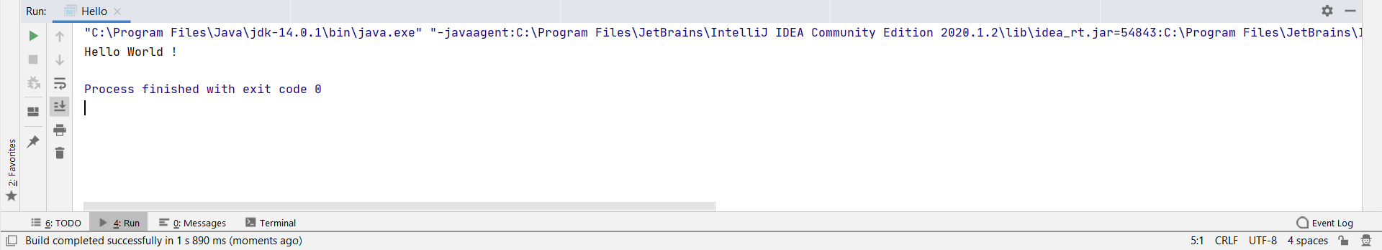

**2.2 Write a program to print addition of two integers.**

Code:

**import** java.util.Scanner;  
**public class** add {

**public static void** main(String[] args) {

Scanner scanner = **new** Scanner(System.***in***);

System.***out***.println(**"Enter first digit:"**);

**int** a = scanner.nextInt();

System.***out***.println(**"Enter second digit:"**);

**int** b = scanner.nextInt();

**int** c = a+b;

System.***out***.println(**"Addition of two digits : "** + c);

}

}

Output:

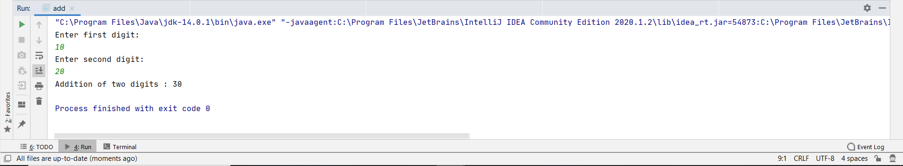

**2.3 Write a program to convert a numeric string into int.**

Code:

**import** java.util.Scanner;  
**public class** string {

**public static void** main(String[] args) {

Scanner scanner = **new** Scanner(System.***in***);

System.***out***.println(**"Enter string:"**);

String s = scanner.nextLine();

**int** number = Integer.*parseInt*(s);

System.***out***.println(**"After parsing the string into Int: "** + number);

}

}

Output:

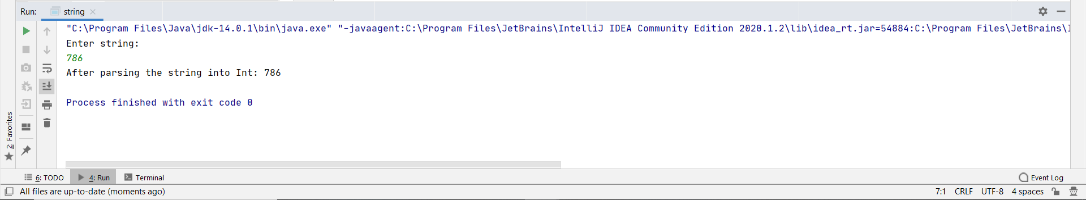

**2.4 Write a program to print addition of two integers input from command line arguments.**

Code:

**public class** PR2_4 {

**public static void** main(String[] args) {

Scanner sc = **new** Scanner(System.***in***);

**int** num1, num2, sum;

num1 = Integer.*parseInt*(args[0]);

num2 = Integer.*parseInt*(args[1]);

sum = num1+num2;

System.***out***.println(num1+**" + "**+num2+**" = "**+sum);

}  
}

Output:

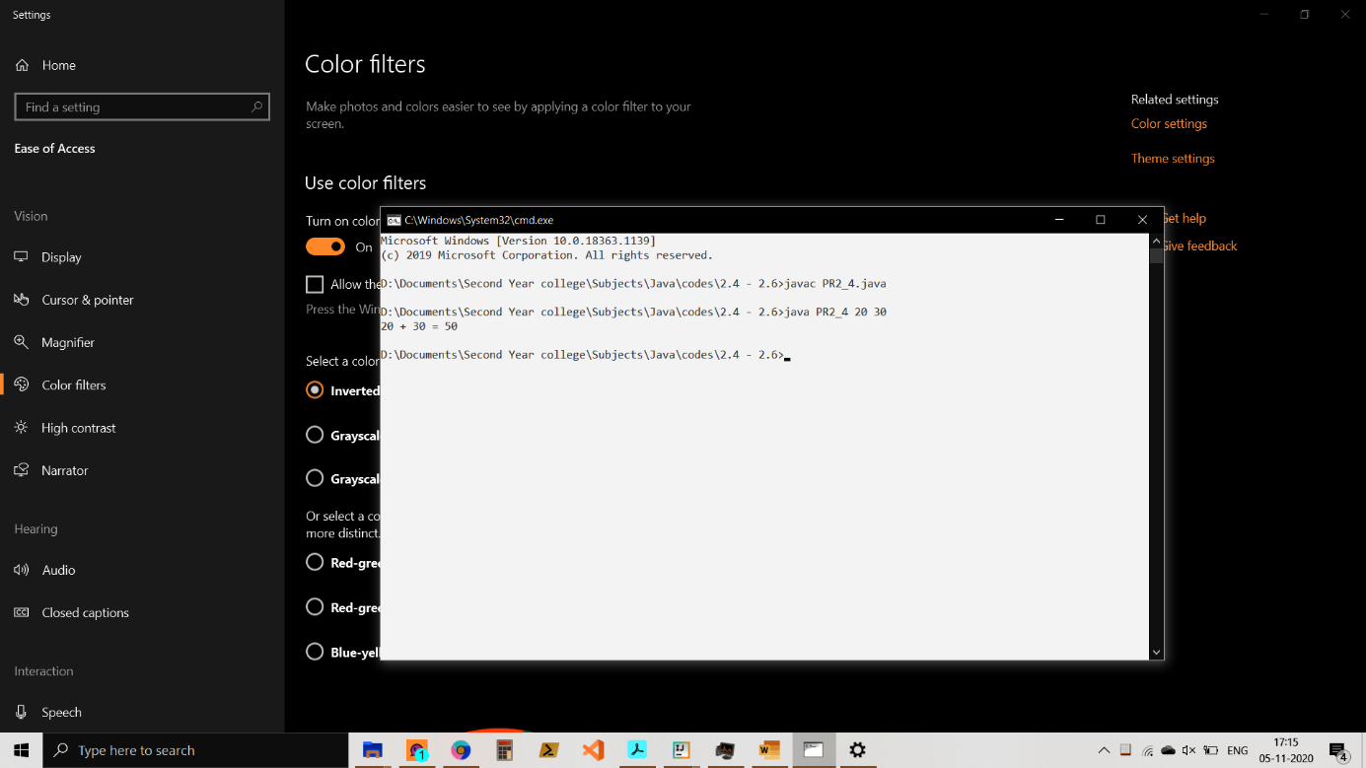\

**2.5 Write a program to take two integers from command line, subtract the smaller number from the greater and print the result.**

Code:

**public class** PR2_5 {

**public static void** main(String[] args) {

Scanner sc = **new** Scanner(System.***in***);

**int** num1, num2;

num1 = Integer.*parseInt*(args[0]);

num2 = Integer.*parseInt*(args[1]);

System.***out***.println(num1>num2 ? num1 +**" - "**+num2+**" = "**+(num1-num2) : num2 +**" - "**+num1+**" = "**+(num2-num1));

}

}

Output :

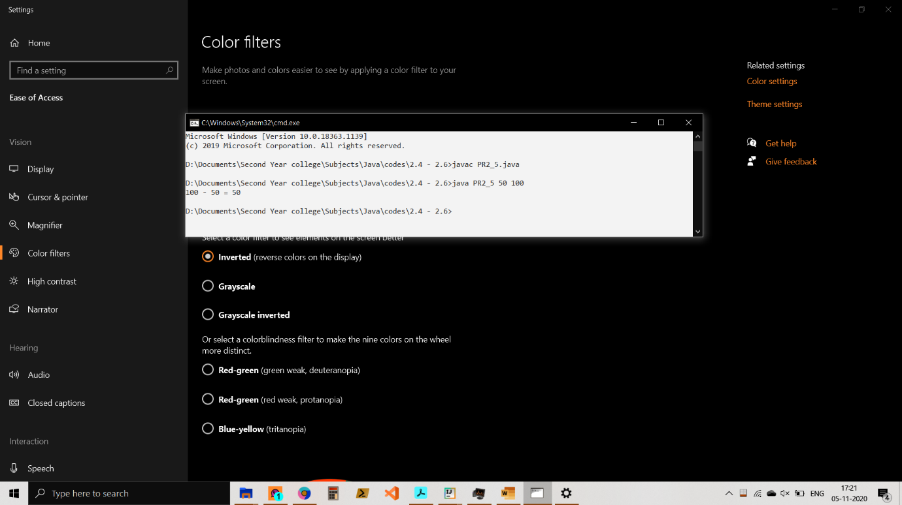

**2.6 Write a program to take n integers from command line and print their sum of product (product of first number and last number added to product of second number and second last number and so on).**

Code:

**public class** EXPERIMENT2_6 {

**public static void** main(String[] args) {

Scanner sc = **new** Scanner(System.***in***);

System.***out***.println(**"Enter the number of elements to get sum:"**);

**int** n = sc.nextInt();

**int** [] arr = **new int**[n];

**int** sum = 0;

**for**(**int** k=0; k<arr.**length**; k++)

arr[k] = sc.nextInt();

**for**(**int** i=0; i<arr.**length**/2; i++){

**int** result = arr[i] + arr[arr.**length**-1-i];

sum += result;

}

**if**(n%2 != 0){  
 **int** middleIndex = ((n-1)/2);  
 sum += arr[middleIndex];  
 }

System.***out***.println(**"The sum of your provided elements are: "**+sum);

}

}

Output:

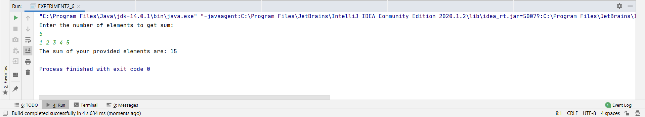

**2.7 Consider any two integers. Write a program to print sum of their squares.**

Code:

**import** java.util.Scanner;  
**public class** int_squares {

**public static void** main(String[] args) {

Scanner sc = **new** Scanner(System.***in***);

**int** a,b,c,d,e;

System.***out***.println(**"Enter first digit:"**);

a=sc.nextInt();  
 b = a*a;

System.***out***.println(**"Enter second digit:"**);

c = sc.nextInt();

d = c*c;

e = b+d;

System.***out***.println(**"Sum of squares of two integers is : "** + e);

}  
}

Output:

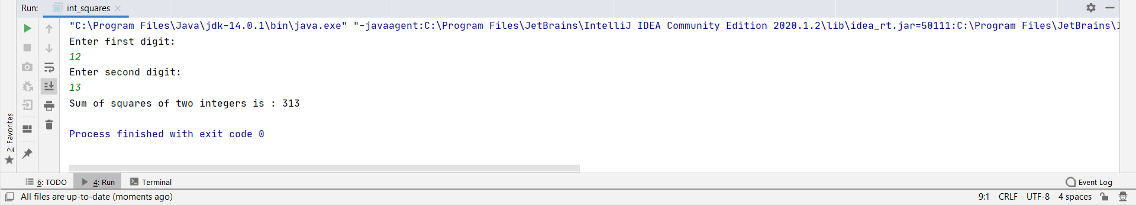

**2.8 Write a program to find square root of a given positive integer using Heron’s method to find square root.**

Code:

**import** java.util.Scanner;

**public class** Heron {

**public static void** main(String[] args) {

Scanner scanner = **new** Scanner(System.***in***);

System.***out***.println(**"Enter The Number : "**);

**int** a = scanner.nextInt();

System.***out***.println((**double**)Math.*round*(*heron*(a) * 10000d) / 10000d);

}

**public static int** ClosetNumber(**int** a) {

**int** i;

a = a - 1;

**while** (a != 0) {

**for** (i = 1; i * i <= a; i++)

{

**if** (i * i == a)

**return** a;

}  
 a = a - 1;

}  
 **return** 0;

}

**public static double** heron(**int** x)

{

**double** a, i;  
 a = *ClosetNumber*(x);

**for** (i = 0; i < 4; i++)

a = 0.5 * (a + x / a);

**return** a;

}  
}

Output :

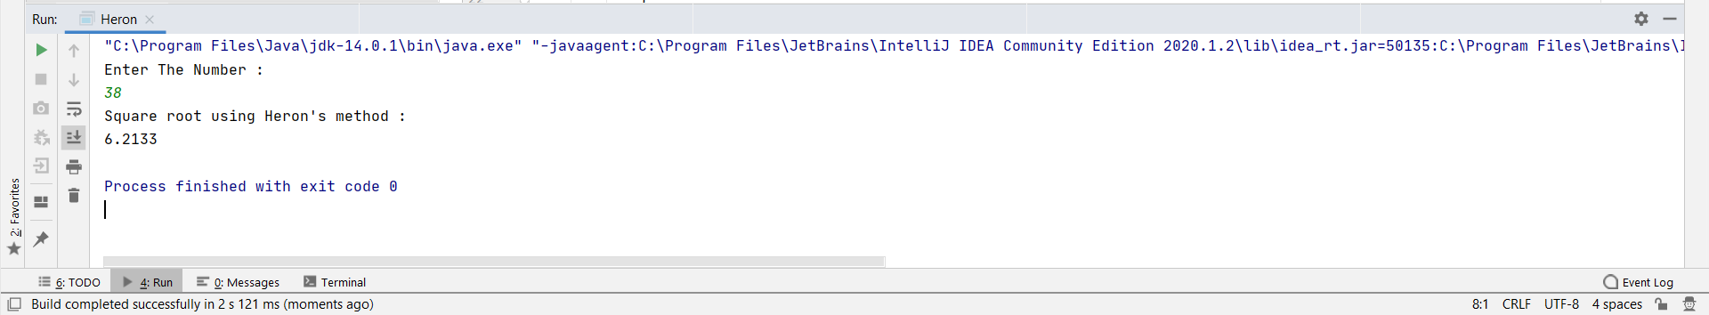

**2.9 Write a program to sort and print the names of students taken from command line in alphabetical order.**

Code :   
**import** java.util.Scanner;  
**public class** Alphabetical_Order  
{  
 **public static void** main(String[] args)  
 {  
 **int** n;  
 String temp;  
 Scanner s = **new** Scanner(System.***in***);  
 System.***out***.print(**"Enter number of names you want to enter:"**);  
 n = s.nextInt();  
 String names[] = **new** String[n];  
 Scanner s1 = **new** Scanner(System.***in***);  
 System.***out***.println(**"Enter all the names:"**);  
 **for**(**int** i = 0; i < n; i++)  
 names[i] = s1.nextLine();  
   
 **for** (**int** i = 0; i < n; i++) {  
 **for** (**int** j = i + 1; j < n; j++) {  
 **if** (names[i].compareTo(names[j])>0) {  
 temp = names[i];  
 names[i] = names[j];  
 names[j] = temp;  
 }  
 }  
 }  
 System.***out***.print(**"Names in Sorted Order:"**);  
 **for** (**int** i = 0; i < n - 1; i++)  
 {  
 System.***out***.print(names[i] + **","**);  
 }  
 System.***out***.print(names[n - 1]);  
 }  
}

Output:

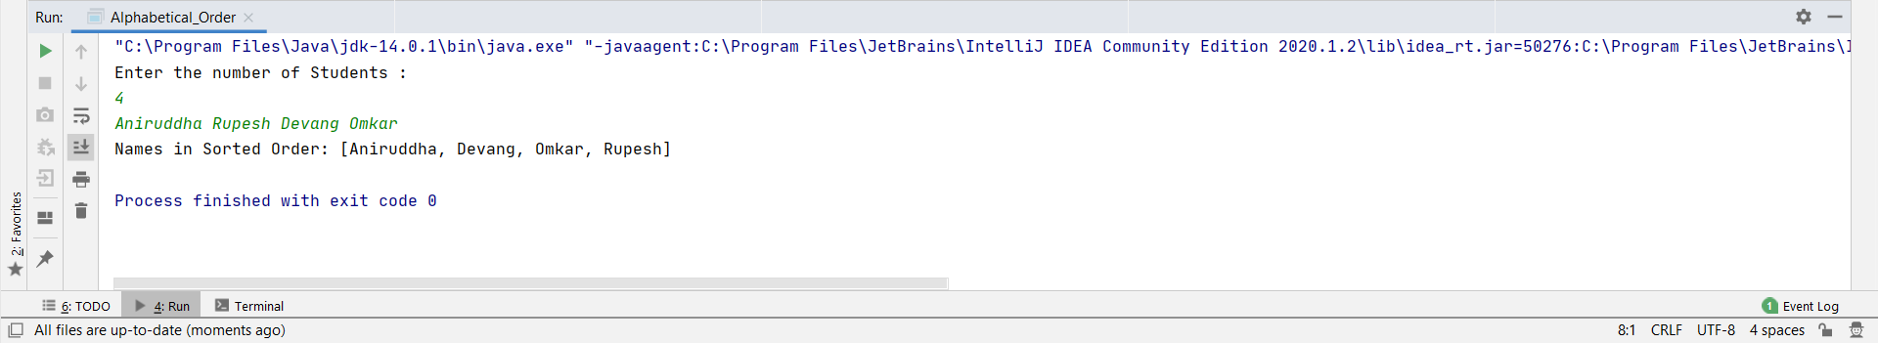

**2.10 Write a program to print total numbers of vowels and consonants in a given string.**

Code:

**import** java.util.Scanner;

**public class** CountVowelConsonant {

**public static void** main(String[] args) {

Scanner sc = **new** Scanner(System.***in***);  
 **int** vCount = 0, cCount = 0;

System.***out***.println(**"Enter the string "**);

String str = sc.nextLine();

str = str.toLowerCase();  
 **for**(**int** i = 0; i < str.length(); i++) {

**if**(str.charAt(i) == **'a'** || str.charAt(i) == **'e'** || str.charAt(i) == **'i'** || str.charAt(i) == **'o'** || str.charAt(i) == **'u'**)

vCount++;

**else if**(str.charAt(i) >= **'a'** && str.charAt(i)<=**'z'**)

cCount++;

}

System.***out***.println(**"Number of vowels: "** + vCount);  
 System.***out***.println(**"Number of consonants: "** + cCount);

}  
}

Output:

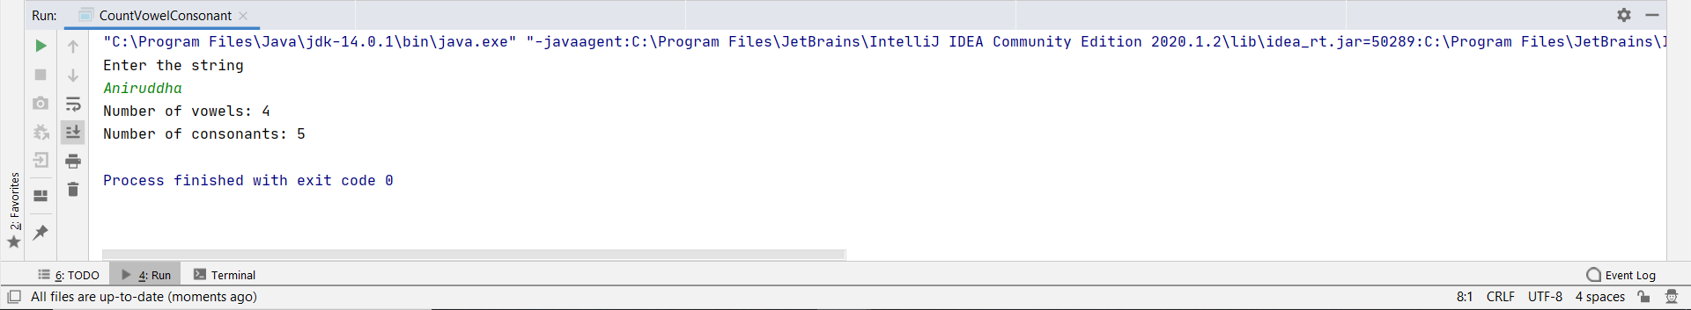

**2.11 Given two English words, write a program to check if the first word is anagram of the second word. ( An anagram is a word or phrase formed by rearranging the letters of a different word or phrase, typically using all the original letters exactly once. (Example: Anagram of TOM MARVOLO RIDDLE is I AM LORD VOLDEMORT.)**

Code:

**import** java.util.Arrays;  
**import** java.util.Scanner;

**public class** Anagram {

**static void** areAnagram(String str1, String str2) {

String s1 = str1.replaceAll(**"\\s"**, **""**);

String s2 = str2.replaceAll(**"\\s"**, **""**);

**boolean** status = **true**;

**int** n1 = s1.length();

**int** n2 = s2.length();

**if** (n1 != n2)  
 status = **false**;

**char**[] ArrayS1 = s1.toLowerCase().toCharArray();  
 **char**[] ArrayS2 = s2.toLowerCase().toCharArray();

Arrays.*sort*(ArrayS1);

Arrays.*sort*(ArrayS2);

status = Arrays.*equals*(ArrayS1, ArrayS2);

**if** (status)  
 System.***out***.println(str1 + **" and "** + str2 + **" are anagrams"**);  
 **else** System.***out***.println(str1 + **" and "** + str2 + **" are not anagrams"**);

}

**public static void** main(String args[]) {

Scanner in = **new** Scanner(System.***in***);

System.***out***.println(**"Enter first string :"**);

String str1 = in.nextLine();

System.***out***.println(**"Enter second string :"**);

String str2 = in.nextLine();

*areAnagram*(str1, str2);

}

}

Output:

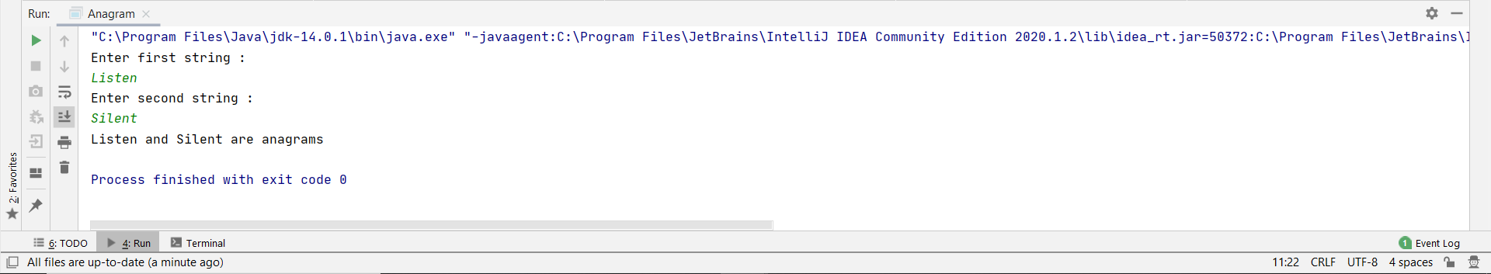

**2.12 Write a program to print a missing number in a sorted integer array.**

**Code:**

**public class** Missing {

**static int** search(**int** arr1[], **int** size)

{

**int** a = 0, b = size - 1;

**int** mid = 0;

**while** ((b - a) > 1)

{

mid = (a + b) / 2;

**if** ((arr1[a] - a) != (arr1[mid] - mid))

b = mid;

**else if** ((arr1[b] - b) != (arr1[mid] - mid))

a = mid;

}

**return** (arr1[mid] + 1);

}

**public static void** main (String[] args)

{

**int** array[] = { 1, 2, 3, 4, 6, 7, 8, 9, 10 };

**int** size = array.**length**;

System.***out***.println(**"Missing number: "** + *search*(array, size));

}

}

Output:

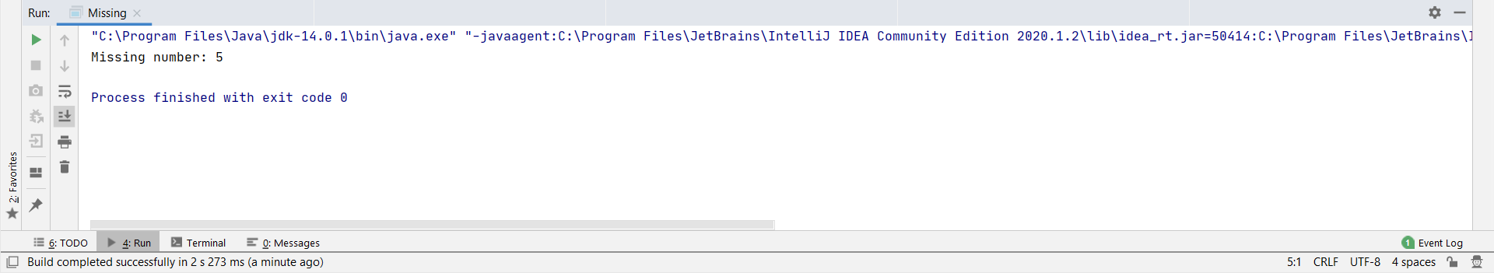

**2.13 Write a program to find all the pairs of numbers on an integer array whose sum is equal to a given number.**

Code:

**import** java.util.Scanner;

**public class** pairsCount {

**static void** showPairs(**int** arr[], **int** n, **int** k) {

**for** (**int** i = 0; i < n; i++)

**for** (**int** j = i + 1; j < n; j++)

**if** (arr[i] + arr[j] == k)

System.***out***.println(**"("** + arr[i] + **", "** + arr[j] + **")"**);

}

**public static void** main(String[] arg) {

Scanner sc = **new** Scanner(System.***in***);

System.***out***.println(**"Enter the number of elements you want to insert: "**);

**int** n = sc.nextInt();

**int** arr[] = **new int**[n];

**for**(**int** i=0; i<arr.**length**; i++){

arr[i]=sc.nextInt();

}

**int** k = 4;

*showPairs*(arr, n, k);

}

}

Output:

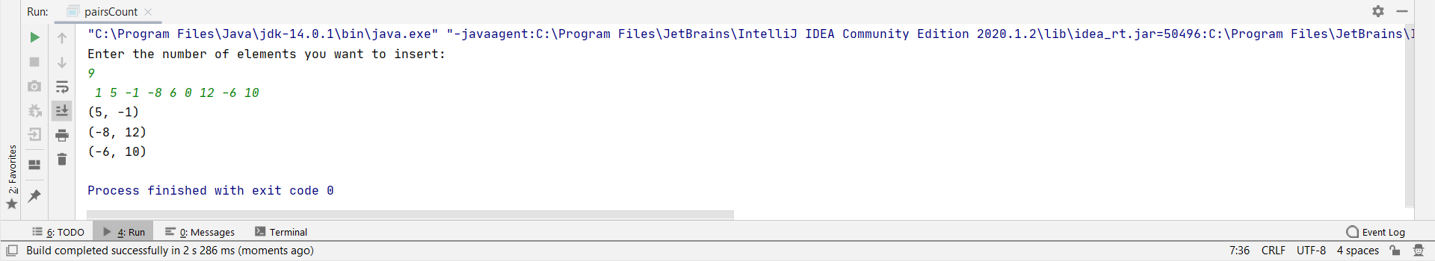

**Conclusion: We understood and performed various programs using Java.**